chudBot. 50% ChatBot, 50% Reels, 100% Awesome.

- Class design — your generic LinkedChain plus the classes that use it. One job per class — the LinkedChain owns storage, not application logic.

// HashMap can be implemented using an array. Each array index will store a linked chain to prevent collisions.
Class HashMap<>
- put(key, val)
- get(key)
- remove(key)
- entrySet()
- Private rehash()

- LinkedChain<T>[]
- Int capacity
- Double load // Choose a capacity at which to copy to larger array to minimize collisions
- Int size

// Used in HashMap implementation. Our code will use its add() and remove() methods for full credit.
Class LinkedChain<T>
Stuff provided

// Message nodes will store messages, the category, and logit probability
Class MessageNode
- String message
- Arraylist<String> themes // In case we want to categorize messages
- Double logit

// Validates clean input by iteratively prompting until an adequate value is provided.
Class DataVal
- Method selectFromOptions(String message, String[] options) // Prompts message and lists acceptable responses. Iterates until a listed option is selected, after which it returns it.
- Method selectFromRange(String message, int min, int max) // Iterates until a number from the range is entered, after which it is returned

- Scanner Input
- String message

// Stores info on keywords omnipresent for the user (listed in interests and hasPremium). Stores method that queries user for account information, which it is capable of displaying.
Class User
- Method signAwayYourSoul // iterates until user agrees to the contract. Method calls after user chooses premium plan
- Method toString // String rep of all info
- Method accountRegistration // Sequentially asks questions to populate user fields.

- Dataval input
- String name = “Guest”
- LL<String> interests = null
- Boolean hasPremium = False // Improved responses from buzzword method if true, else ads

// The computational veggie. Parses user info for keywords, stores message bank, samples from messages to talk with user, updates message logits based on conversation effectiveness, adds user messages to its own masterList, prunes unlikely messages to remain computationally fast, lower N in bigO.
Class Response
- Private Method readUserMessage(String message) // Traverse each word of message and put in isUserKeyword if it exists in isMasterKeyword
- Method sampleBotMessage() // One forward pass through theMasterList, increasing logit for every theme that occurs in isUserKeyword (including ad if user is on unpaid plan), then adding from Gumbel distribution and taking max logit.
- Method learn(HashMap<String message, Float Score> History, Float score) // Calls readUser message on each to get keywords, then it adds message and corresponding metadata as new item in theMasterList. Then, it updates the logits of used message theMasterList with those in history. Finally, it modifies the logits by adding ax + b, where a and b are decided by the developer and x is the survey score.
- Private Method distill(int num) // Removes minimum logits from theMasterList (excluding adds) until only num items remain

- HashMap<String message, MessageNode data> theMasterList
- HashMap<String message, Boolean inUserMessage> isMasterKeyword
- HashMap<String keyword, Boolean inBotMessage> isUserKeyword

// Stores message history, takes messages from user and outputs messages from Response, calculates score from postsurvey and message effectiveness from RL policy
Class Convo(User user)
- Method postsurvey() // Takes in 1-10 rating from player of how convo went
- Method ScoreMessages(HashMap<String message, Float Score> History) // Gives reward based on decaying RL policy adding total future words and total future messages. Returns History

- DataVal input
- Response botMessages
- User user
- Double score
- HashMap<String message, Float Score> History
- Private Double[] messageScore

// Menu with options:
// (View Account / New User / Start Convo / Quit)
Class Main()
- User user
- Convo convo

We designed it this way because one class starts the program, one class holds user info, one class manages conversations, and one class controls bot responses. Each class has its own purpose, and each aspect of the User interaction is demarcated.

- System diagram
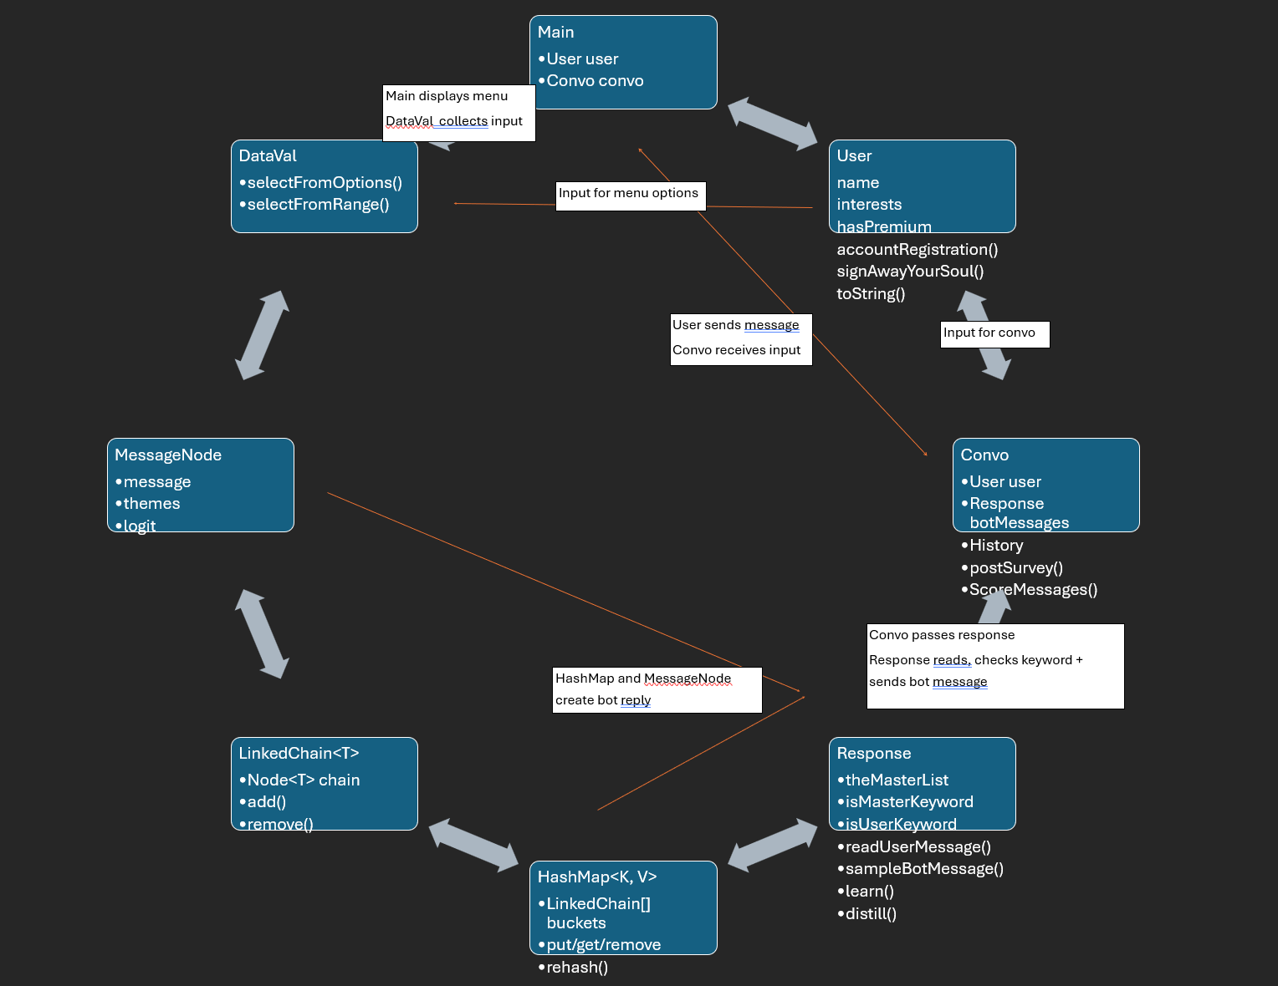

- The generic contract — declare your type parameter and any bound. What does LinkedChain<T> promise about T, and which operations are type-safe?
LinkedChain<T> will be used to store user interests, message information, and connection between multiple chatbot messages associated with a keyword, which allows the chatbot to choose a related response.
Type parameter: T, with no upper bound to store different objects so objects are not required to belong to a specific class.
The generic contract guarantees:
- Every entry stored in the chain has type T
- Entries returned by methods (like remove(), get(int index), etc.) have type T
- The chain can store objects like String without changing them or their implementation
- Operations accept arguments that are type T, such as add(T newEntry), providing compile-time type safety
- The LinkedChain should maintain size as elements are added and removed
- Duplicate entries are allowed, and entries aren’t rejected just because an equivalent entry exists
- Entries are also not required to be sorted
Type safe operations:
- add(T newEntry) and addToEnd(T newEntry) return a boolean for successful or unsuccessful insertion
- remove(T anEntry) returns a boolean for the removal of an entry
- get(int index) return a type T entry for the given index
- contains(T anEntry) and count(T anEntry) take type T values and returns a boolean for contains and an int for count
- toArray(T[] values) copies entries into an array with type T
- clear(), size(), isEmpty(), and toString operate operate on the LinkedChain without returning any value

- Data & state — what backs the LinkedChain (your node class, head/tail references, how size is tracked?), and for each class, the fields it holds and their types.
- LinkedChain<T>
(type T) class owns storage and organization of its entries. Each node holds one type T element and a reference to the next node (Next, which is null if empty). The state is also managed when adding or removing an element for size. References are also managed using head (the first node in the chain which is null if empty) and tail (final node in the chain and is null if empty) nodes. int size tracks the number of elements stored. The LinkedChain allows duplicate entries and does not require entries to be sorted.
- HashMap<K, V> Key-Value Storage
The HashMap stores key-value pairs and uses an array of linked chains to handle collisions. A bucket array has type LinkedChain<Entry<K, V>>[] and stores key-value entries in the chain at the appropriate position. Other fields include int capacity to track the number of buckets in the array, double load to track the load factor used to determine map resizing, and int size to track the number of key-value pairs stored
- MessageNode - Chatbot Response Data
This class represents potential responses the chatbot can display. Field string message stores chatbot response text, themes (type ArrayList<String> stores topics associated with the message, and double logit stores the response weight, which is adjusted as the chatbot continues discussions with the user.
- DataVal - for input validation
This class manages user input and validates it, taking Scanner type input from user response and a String message for the prompt displayed to the user
- User - Account information
Stores information about the user, including their (String) name, (LinkedChain<String>) interests, and whether or not the user hasPremium (boolean). The user class also takes an input field with type DataVal
- Response - Message bank and response
This class manages the chatbot’s message bank, recognizes potential keywords, and selects responses. It has fields theMasterList (type HashMap<String, MessageNode>) which stores chatbot messages as keys and associated MessageNode objects, isMasterKeyword (type HashMap<String, Boolean>) which stores recognized keywords, and isUserKeyword (type HashMap<String, Boolean>) which stores keywords used in user’s message chat with the chatbot.
- Convo - Conversation history
This class manages individual conversations and tracks messages, collecting feedback as well. It contains fields input (type DataVal), bothMessages (type Response), user (type User), double score, History (type Hashmap<String, Float>) and Double[] messageScore.
- Main
Main integration and connection of the program for functionality, contains field user (type User) which references the current user and convo (type Convo) which references the current conversation.

- Method signatures — the public API of your LinkedChain (add, remove, contains, count, size, …) along with any modifications you made to it and of your app classes: name, parameters and types, return type, and a one-line behavior. This is the contract a teammate or GenAI builds against. Include a short, estimated Big-O time complexity for each method. It is important to consider these constraints before implementing methods.
LL API
public LinkedChain();

public LinkedChain(); // Creates an empty linked chain
public boolean add(T newEntry); // O(1) // TCJ First element is accessed // Adds an entry to the front of the chain
public boolean addToEnd(T newEntry); // O(N) // TCJ Each node is traversed // Adds an entry to the end of the chain
public T remove(); // O(1) // TCJ First node is removed // Removes and returns the first entry
public boolean remove(T anEntry); // O(N) // TCJ Each node is traversed // Removes the first occurrence of the specified entry
public void clear(); // O(1) // TCJ Field is set to null // Removes all entries from the chain
public T get(int index); // O(N) // TCJ All nodes are traversed if N=len(LL)-1 // Returns the entry at the specified index
public boolean contains(T anEntry); // O(N) // TCJ All nodes are traversed if LL does not contain val // Checks whether the chain contains the specified entry
public int count(T anEntry); // O(N) // TCJ All nodes are traversed // Returns the number of times the specified entry occurs
public int size(); // O(1) // TCJ A field is accessed // Returns the number of entries in the chain
public boolean isEmpty(); // O(1) // TCJ A field is accessed // Checks whether the chain is empty
public T[] toArray(T[] values); // O(N) // TCJ Each node is traversed // Copies all entries into the specified array
public String toString(); // O(N) // TCJ Each node is traversed // Returns a string representation of the chain

Class HashMap<>
- put(key, val)
  - O(1) // TCJ Hashes input and indexes array
- get(key)
  - O(1) // TCJ Hashes input and indexes array
- remove(key)
  - O(1) // TCJ Hashes input and indexes array
- entrySet()
  - O(n) // TCJ Traverses map and adds to array
- Private rehash()
  - O(n) // TCJ Traverses map and puts each item in new map

Class DataVal
- Method selectFromOptions(String message, String[] options)
  - Trivial
- Method selectFromRange(String message, int min, int max)
  - Trivial

Class User
- Method signAwayYourSoul
  - Trivial
- Method toString
  - Trivial
- Method accountRegistration
  - Trivial

Class Response
- Private Method readUserMessage(String message)
  - O(# of words in message) → O(N) // TCJ each word is traversed and then fixed ops are performed on it
- Method sampleBotMessage()
  - O(len(theMasterList)) → O(N) // TCJ each masterList item is traversed, and its values are modified in O(1)
- Method learn(HashMap<String message, Float Score> History, Float score)
  - O(len(userMessage) * len(History)) → O(N^2) // TCJ if History is N, then each element of N is traversed, which is O(N). Also, for each of the user messages, each word is iterated over, which is O(N/2) = O(N) for the messages * O(len(message)) for the words traversed.
- Private Method distill(int num)
  - O(N^2) // TCJ Each value of theMasterList is traversed and the least likely message is removed. This happens num times

Class Convo(User user)
- Method postsurvey()
  - O(1) // TCJ Just user interaction. No scaling data
- Method ScoreMessages(HashMap<String message, Float Score> History)
  - O(total # words for all messages of History) + len(History)^2) → O(N^2) // TCJ The words for each message are counted, and that count populates an array element for each word, equivalent to O(# of words). Then, each element array is traversed, and their values are shifted and updated to remain consistent with the LR decay. This update occurs to each message in the array, and updates occur n times since each message gets a rating, making O(len(History)^2). This is added to O(# of words) for final complexity

Nothing changed about the LL

- Where validation lives — take each bad-input case from your scope: which class/method catches it, and what happens (re-prompt, exception, default)?
DataVal:
- Handles bad input from the user provided by the Main class for menu choices (invalid choice selections, out of range)
- Will re-prompt
Response:
- Handles input that is blank, w/o keyword
- Adds new keywords, picks from bank if blank
- Test plan — for each public method, one normal case and one bad-input case: input and expected result, in plain English.
Class HashMap<>:
- put(key, val)
  - Normal: Add strings “football” with definitions to test adding
  - Bad input: Add null and make sure it gets rejected
- get(key)
  - Normal: have an entry then test it with its key
  - Bad input: try to get a null object
- remove(key)
  - Normal: remove an existing definition and make sure it doesn’t still exist
  - Bad input: try to remove a key that isn’t in it
- entrySet()
  - Normal: add two entries then call this to test if it returns the proper length which would be two
  - Bad input: run on an empty dictionary

Class LinkedChain:
- Add()
  - Normal: Add two strings “football” to test duplicates
  - Bad input: Add null and make sure it gets rejected
- remove()
  - Normal: Add two strings “football” and “homework” then remove one and test the output and make sure its removed
  - Bad input: remove an item that’s not in the list
- contains()
  - Normal: Add a string “football” to test if it contains
  - Bad input: contains null and make sure it doesn’t throw an exception
- size()
  - Normal: add two strings and make sure it returns 2
  - Bad input: check an empty chain length

Class MessageNode:
- Normal: Create a node with "Go Hokies!", themes ["football"], logit 0.0. The getters return those values.
- Bad input: A node with a null message will throw an error.

Class DataVal:
- Method selectFromOptions(String message, String[] options)
  - Normal: input only allowed to be one of the options from a list
  - Bad input: user inputs an input not in the list and make sure it can handle it
- Method selectFromRange(String message, int min, int max)
  - Normal: only allows an input in a range so input a value in the range and make sure it runs
  - Bad input: a value not in the range or not an int so it doesn’t parse and make sure it can handle it.

Class User:
- Method signAwayYourSoul
  - Normal: user agrees and it moves on
  - Bad Input: user doesn’t agree
- Method toString
  - Normal: Converts data in user to string and could check output to make sure all of it is right
  - Bad input: one of the data values is null so it throws an error
- Method accountRegistration
  - Normal: Asks user to input user information and could test that it was all created properly
  - Bad input: User inputs a blank field so the name is not saved properly which can be checked and throw a new exception

Class Response:
- Method sampleBotMessage()
  - Normal: Over time when certain topics are talked about more they will be called more so call certain topics then make sure the topic is weighted
  - Bad input: There are no keywords so nothing can get a weight.
- Method learn(HashMap<String message, Float Score> History, Float score)
  - Normal: The user will input a ranking of the chat which will weight the topics used so try to input a conversation and rank.
  - Bad input: user does not input a ranking so it cannot learn allow it to parse with a base weight

Class Convo(User user):
- Method postsurvey()
  - Normal: takes int input and keeps rating in data structure
  - Bad input: not an input and calls method again
- Method ScoreMessages(HashMap<String message, Float Score> History)
  - Normal: The user ranks the conversations so then they get weighted for future conversations.
  - Bad input: An empty history or the user not responding could cause an error so make sure it has defaults when the inputs are blank.

Class Main: runs interface between all classes and objects with no methods

The section before here was done by Luke with some small help from Claude to explain topics like RL and logits.

- Revised scope — what changed since your scope doc and why, and where each change originated (group discussion, GenAI, your own reflection)?
- HashMap of LinkedChains replaced the plain string chains. Messages are MessageNodes now. Origin: group discussion.
- Dropped the ChatEntry and bad-input log chains. Input is now trimmed and fixed before inputted into the chatbot. Origin: group discussion.
- Moved the RL and topic-based responses into the core. sampleBotMessage() uses themes that were mentioned. Origin: group discussion and our own reflection.
- Added learning and pruning. Origin: Gabe with the most knowledge on this part decided it would be best.
- Replaced Buzzword with keyword HashMaps. readUserMessage() compares words with the keyword dictionary. Origin: group discussion.
- Added DataVal for re-prompting. It handles option and range validation. Origin: group discussion.
- Kept premium and ads but are in another class. Origin: group discussion.
- Dropped the admin class, the text game, and the time function. They added more problems to deal with. Origin: group discussion and our own reflection.

The section before here was done by Luke with the use of Claude to explain some terms that others know that I don’t

- Work Attribution (REQUIRED) — every section of this document must be attributed. Include a table with one row per section listing who worked on it and how (drafted, revised, reviewed, diagrammed, GenAI-assisted, …). Additionally, note the way in which you used GenAI, if at all. Unattributed sections are treated as incomplete and group members not contributing substantively to at least one section will receive a 50% deduction on their group's deliverable.

Gabe | Class Design  Method Signatures | All done using my brain except I used BERT for the Gumbel Distribution.  I did half of the method signs and chat did the other half because I thought it was grunt work
Hooriah | System Diagram  Where Validation Lives | Used Gen AI to simulate a simple flow of information to aid in creating system diagram  Traced flow to identify which classes handle bad input
Luke | Test Plan  Revised Scope | Did not use GenAI  Reviewed scope to develop test plans and bad input cases
Blake | The Generic Contract  Data and State | Drafted and revised these sections. Reviewed with Gen-AI to ensure all questions have been covered thoroughly, as well as Gen-AI for new terms

Example User Interaction

What is your name: Luke
What is your age: 18
What are your interests: (coding/VT/sports/food)

Okay. Please enter a prompt to begin:

When is the football game this week?

// Picks up on keyword football
Football! Are you talking about the VT game? Go Hokies!

So do you know what day the football game is?

// Picks up on keywords ‘day’ and ‘football’
Football day is today? Hooray! I will totally watch later

So the game is today????

// No keyword, chooses from responseBank

The earth is actually spherical, that’s why it has a circular shadow during a lunar eclipse!

Huh. That’s weird.

// No keyword, chooses from responseBank
I agree, what do you think?

// User gets bored
STOP

Program Stopped
// responses in history that are in the response bank are updated like:
For r in responseHistory
responseBank.get(r) += .9^(len(responseHistory)-i) * (len(responseHistory) - 10)

Survey:
Rate this convo (1-10): 3
responseBank.get(r) *= (rating - 5)/5

Would you like to go again: No

Bye

